Ex.no:2 | EDA-DATA IMPORT AND EXPORT

Aim:
To inspect dataset features, detect null values, and export data into CSV, Excel, and SQLite database formats.
Algorithm:
- Import Pandas and sqlite3 libraries.
- Read the Fashion_Products_Output.csv using pd.read_csv().
- Inspect the data structure using .head(), .tail(), .info(), .describe(), and .isnull().sum().
- Export the DataFrame to CSV and XLSX formats using .to_csv() and .to_excel().
- Connect to fashion_products.db using sqlite3 and write the data into an SQL table using .to_sql().
- Close the database connection and end execution.
Program:
import pandas as pd
import sqlite3
from google.colab import files

uploaded = files.upload()
path = list(uploaded.keys())[0]

print("Dataset path:", path)

df = pd.read_csv(path)

print("\nFirst 5 rows:")
display(df.head())

print("\nLast 5 rows:")
display(df.tail())

print("\nDataset information:")
df.info()

print("\nStatistical description:")
display(df.describe())

print("\nMissing values:")
display(df.isnull().sum())

df.to_csv("Fashion_Products_Output.csv", index=False)
df.to_excel("Fashion_Products_Output.xlsx", index=False)

print("\nCSV and Excel files created successfully.")

conn = sqlite3.connect("fashion_products.db")

df.to_sql("fashion_products", conn, if_exists="replace", index=False)

print("\nFashion Products data successfully written to SQL table.")

conn.close()

print("\nDatabase connection closed successfully.")
print("\nExperiment 2 completed successfully.")

Output:
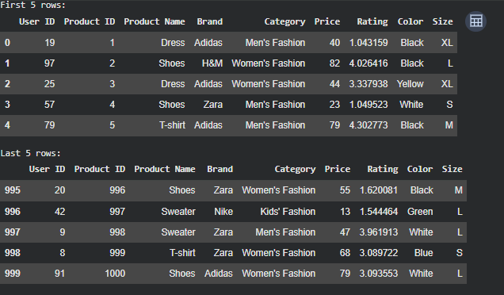

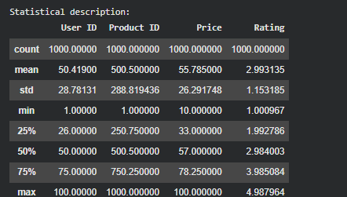
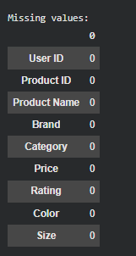

Result:

